1. **INTRODUCTION**

The web-based application titled “Agricultural Products Trading Platform” is an attempt to automate the trading of agricultural products across the country. The platform allows sellers to publish their agricultural products and can be found by genuine and bulk buyers across the country. The platform removes the hurdle of taking the produces to the market, or searching for buyers in the same village and allows sellers to sell their products across India, where he/she can expect the best prices and also removes the presence of middlemen who charges a hefty amount.

The platform also displays the current weather in the same area where the seller belongs to. Using this feature, seller can decide what to grow next. The platform also provides current market prices of their produces by comparing with APMC data. If the seller is not getting what he deserves, he/she can always opt for APMC.

The user(seller/buyer) first needs to create a free account on the platform. After selecting his appropriate role, the functionalities change accordingly. If the new user created is a seller, he/she can list his products, search for buyer. If the new user is a buyer, he/she can search for the required product, and if the product is not available, he/she can always put his/her requirements on the platform. And if the new user is Admin, he/she can inspect all the orders executed and their respective transactions on the platform, he/she can also see all the registered users and can remove fake profiles.

1. **FUNCTIONAL REQUIREMENTS**

* **CLASS-FLOW DIAGRAM:**

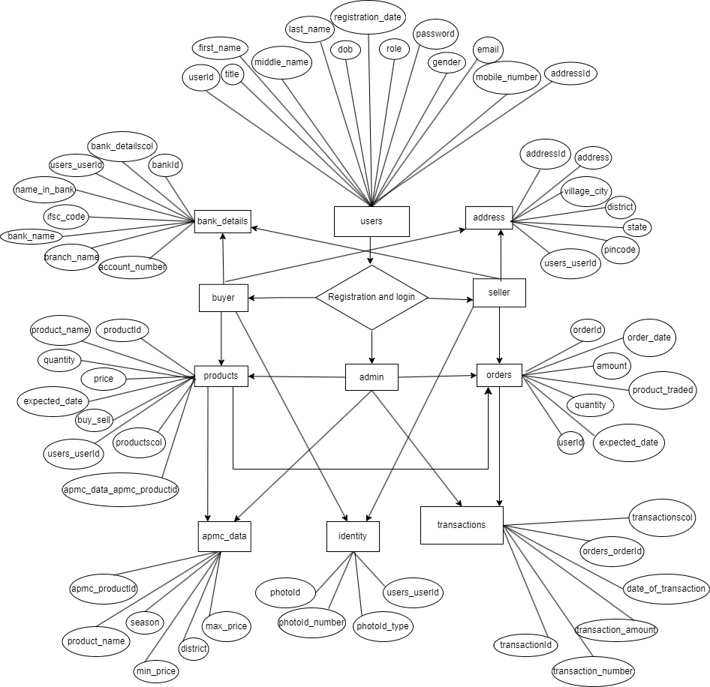

The person who visits the platform for the first time will be henceforth called as ‘user’, will be redirected to registration form, where he/she can register as either seller/buyer.

**2.1: SELLER:**

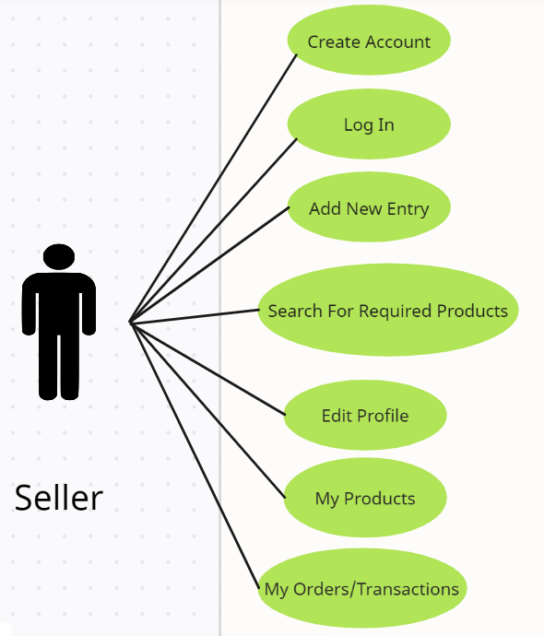

**2.1.1: CREATE ACCOUNT:**

* The user who selects ‘Seller’ as the role will be able to register himself/herself as seller.
* On this page, he/she can register on the platform. Registration is must to login and use the other functionalities.
* Every new user will be assigned a unique ‘User-ID’ on successful completion of the registration form.
* The seller has to select the appropriate title.
* The seller has to enter his/her first-name, middle-name and last-name.
* The seller has to enter his/her date of birth.
* The registration-date will be automatically added to the database.
* The role field will decide the role of the user. Here the role is seller.
* The seller has to enter a new password. Seller has to confirm the password.
* The seller has to select the gender.
* The seller has to enter his/her e-mail. E-mail will be used for login purpose in the future.
* The seller has to enter his/her mobile number for communication.
* The seller has to submit any government approved identity for verification. The id can be Aadhar-card, PAN-card. The seller has to select his/her id-type, id-number, etc.
* The seller has to enter his full address including village, district, state and pin-code. This address will help buyers to identify their nearest sellers.
* The seller has to enter his/her bank details like account number, IFSC, bank name, etc.

**2.1.2: LOG IN:**

* The seller can now log in to the platform using the credentials.
* The username field will require to enter the e-mail id, as e-mail id is the primary login credential.
* The seller has to enter the same password that was entered while registering.
* After clicking on ‘Login’ button, the credentials will be verified from the database and the seller will be able to login to his/her account, if the credentials are valid.
* The seller will be redirected to the dashboard, where he/she can see and use other functionalities.

**2.1.3: ADD NEW ENTRY:**

* On this page, the seller can enter his/her product details that he/she wishes to sell.
* This functionality requires seller to enter various details like product name, the quantity available for selling, the expected price, and the date from which the product is available for buying.
* After successful completion, every product will be added to the database and will be assigned a unique ‘Product-ID’ and the ‘User-ID’ of the seller.
* Now, this product is live on the platform for selling.

**2.1.4: SEARCH FOR REQUIRED PRODUCT:**

* The seller can search for any pending request on the platform. On this page, seller will be able to search for any requirements, that a buyer has added.
* The seller then can directly contact the buyer, if he/she has the matching required product and matches with his/her expectations.

**2.1.5: EDIT PROFILE:**

* On his page, seller will be able to change his/her basic details like name, contact details, bank details, etc.
* The seller can update all the required fields except the primary e-mail id.

**2.1.6: MY PRODUCTS:**

* On this page, seller can check his/her listed products. All the products that are linked to a particular ‘User-ID’ will be displayed here.
* The seller can update the product details, if required.

**2.1.7: MY ORDERS/TRANSACTIONS:**

* On this page, seller will be able to review his/her previous orders. If there occurs a deal between buyer and seller, then only the particular executed order will be displayed here.
* Seller can check the order date, amount, the product traded, quantity of the product traded.
* Also, seller can check the transaction details for that particular order on the same page.

**2.2: BUYER:**

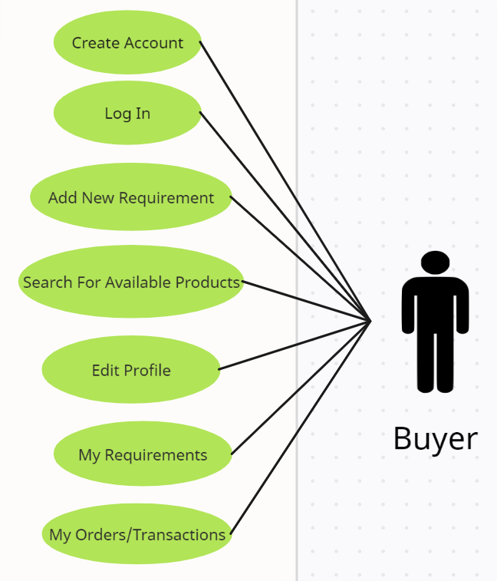

**2.2.1: CREATE ACCOUNT:**

* The user who selects ‘Buyer’ as the role will be able to register himself/herself as buyer.
* On this page, he/she can register on the platform. Registration is must to login and use the other functionalities.
* Every new user will be assigned a unique ‘User-ID’ on successful completion of the registration form.
* The buyer has to select the appropriate title.
* The buyer has to enter his/her first-name, middle-name and last-name.
* The buyer has to enter his/her date of birth.
* The registration-date will be automatically added to the database.
* The role field will decide the role of the user. Here the role is buyer.
* The buyer has to enter a new password. Seller has to confirm the password.
* The buyer has to select the gender.
* The buyer has to enter his/her e-mail. E-mail will be used for login purpose in the future.
* The buyer has to enter his/her mobile number for communication.
* The buyer has to submit any government approved identity for verification. The id can be Aadhar-card, PAN-card. The buyer has to select his/her id-type, id-number, etc.
* The buyer has to enter his full address including village, district, state and pin-code. This address will help sellers to identify their nearest buyers.
* The buyer has to enter his/her bank details like account number, IFSC, bank name, etc.

**2.2.2: LOG IN:**

* The buyer can now log in to the platform using the credentials.
* The username field will require to enter the e-mail id, as e-mail id is the primary login credential.
* The buyer has to enter the same password that was entered while registering.
* After clicking on ‘Login’ button, the credentials will be verified from the database and the buyer will be able to login to his/her account, if the credentials are valid.
* The buyer will be redirected to the dashboard, where he/she can see and use other functionalities.

**2.2.3: ADD NEW REQUIREMENT:**

* On this page, the buyer can enter his/her product details that he/she wishes to buy.
* This functionality requires buyer to enter various details like product name, the quantity required, the expected price, and the date on which the product is required.
* After successful completion, every requirement will be added to the database and will be assigned a unique ‘Product-ID’ and the ‘User-ID’ of the seller.
* Now, this requirement is live on the platform for sellers to see.

**2.2.4: SEARCH FOR AVAILABLE PRODUCT:**

* The buyer can search for required product on the platform. On this page, buyer will be able to search for any products, that a seller has added.
* The buyer then can directly contact the seller, if he/she has the required product and matches with his/her expectations.

**2.2.5: EDIT PROFILE:**

* On his page, buyer will be able to change his/her basic details like name, contact details, bank details, etc.
* The buyer can update all the required fields except the primary e-mail id.

**2.2.6: MY REQUIREMENTS:**

* On this page, buyer can check his/her listed requirements. All the requirements that are linked to a particular ‘User-ID’ will be displayed here.
* The buyer can update the requirement, if required.

**2.2.7: MY ORDERS/TRANSACTIONS:**

* On this page, buyer will be able to review his/her previous orders. If there occurs a deal between buyer and seller, then only the particular executed order will be displayed here.
* Buyer can check the order date, amount, the product traded, quantity of the product traded.
* Also, buyer can check the transaction details for that particular order on the same page.

**2.3: ADMIN:**

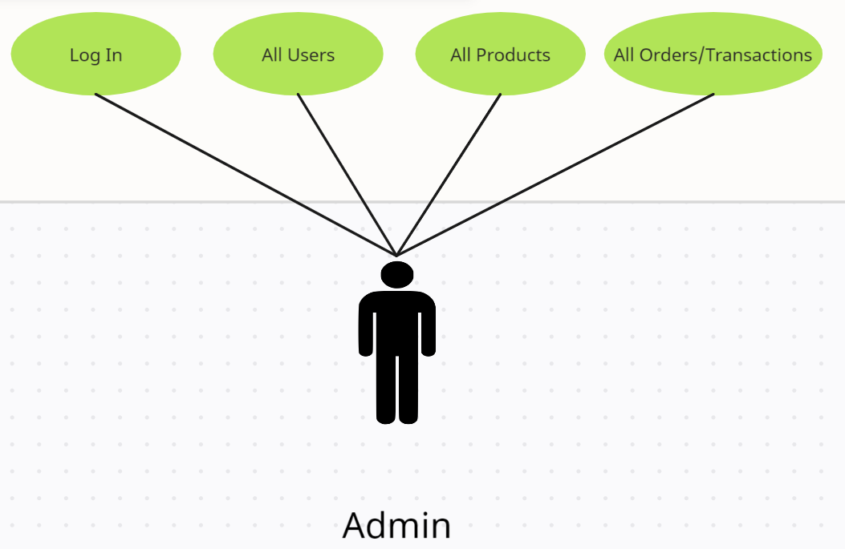

**2.3.1: LOG IN:**

* The admin can now log in to the platform using the credentials.
* The admin credentials will be added to the database directly.
* The admin has to enter the same e-mail id and password that was entered in the database.
* After clicking on ‘Login’ button, the credentials will be verified from the database and the admin will be able to login to his/her account, if the credentials are valid.
* The admin will be redirected to the dashboard, where he/she can see and use other functionalities.

**2.3.2: ALL USERS:**

* The admin can check all the registered users on the platform. Admin can inspect all the details of sellers, buyers. Admin has a filter to categorise users on the basis of their roles viz. buyer, seller, admin.
* Admin can delete any suspicious or inactive user from the database.

**2.3.3: ALL PRODUCTS:**

* On this page, admin can check all the products listed by sellers.
* Also, admin can check all the pending requirements from the buyers.

**2.3.4: ALL ORDERS/TRANSACTIONS:**

* On this page, admin will be able to review all the previous orders. If there occurs a deal between a buyer and a seller, then only the particular executed order will be displayed here.
* Admin can check the order date, amount, the product traded, quantity of the product traded.
* Also, admin can check the transaction details for that particular order on the same page.

1. **PROJECT DESIGN**

The project design has been divided into 3 stages, viz.

1. Database design.
2. Back-end development.
3. Front-end development.
4. Security.
5. Integration.
6. Deployment.

**3.1: DATABASE DESIGN:**

**3.1.1: TABLE STRUCTURE:**

The following table structure depict the database design.

* Table 1: Users

|  |  |  |  |  |  |
| --- | --- | --- | --- | --- | --- |
| **FIELD** | **TYPE** | **LENGTH** | **KEY** | **DEFAULT** | **EXTRA** |
|  |  |  |  |  |  |
| User_id | bigint | - | PRI | NULL | auto_increment |
| Email | varchar | 40 | - | NULL | - |
| Title | varchar | 10 | - | NULL | - |
| First Name | varchar | 20 | - | NULL | - |
| Middle Name | varchar | 20 | - | NULL | - |
| Last Name | varchar | 20 | - | NULL | - |
| DOB | date | - | - | NULL | - |
| Gender | varchar | 20 | - | NULL | - |
| Password | varchar | 255 | - | NULL | - |
| Mobile Number | varchar | 14 | - | NULL | - |
| Registration Date | date | - | - | NULL | - |
| Role | varchar | 25 | - | NULL | - |
| Address_id | bigint | - | MUL | NULL | - |
| Bank_Details_id | bigint | - | MUL | NULL | - |
| Identity_id | bigint | - | MUL | NULL | - |

* Table 2: Address

|  |  |  |  |  |  |
| --- | --- | --- | --- | --- | --- |
| **FIELD** | **TYPE** | **LENGTH** | **KEY** | **DEFAULT** | **EXTRA** |
|  |  |  |  |  |  |
| Address_id | bigint | - | PRI | NULL | auto_increment |
| Address | varchar | 150 | - | NULL | - |
| Village | varchar | 30 | - | NULL | - |
| District | varchar | 30 | - | NULL | - |
| Pincode | varchar | 12 | - | NULL | - |
| State | varchar | 30 | - | NULL | - |

* Table 3: Bank_details

|  |  |  |  |  |  |
| --- | --- | --- | --- | --- | --- |
| **FIELD** | **TYPE** | **LENGTH** | **KEY** | **DEFAULT** | **EXTRA** |
|  |  |  |  |  |  |
| Bank_details_id | bigint | - | PRI | NULL | auto_increment |
| Account Holder Name | varchar | 45 | - | NULL | - |
| Account Number | varchar | 30 | UNI | NULL | - |
| Bank Name | varchar | 40 | - | NULL | - |
| Branch | varchar | 22 | - | NULL | - |
| IFSC | varchar | 30 | - | NULL | - |

* Table 4: Identity

|  |  |  |  |  |  |
| --- | --- | --- | --- | --- | --- |
| **FIELD** | **TYPE** | **LENGTH** | **KEY** | **DEFAULT** | **EXTRA** |
|  |  |  |  |  |  |
| Identity_id | bigint | - | PRI | NULL | auto_increment |
| Identity Type | varchar | 20 | - | NULL | - |
| Identity Number | varchar | 30 | - | NULL | - |

* Table 5: APMC Data

|  |  |  |  |  |  |
| --- | --- | --- | --- | --- | --- |
| **FIELD** | **TYPE** | **LENGTH** | **KEY** | **DEFAULT** | **EXTRA** |
|  |  |  |  |  |  |
| Id | bigint | - | PRI | NULL | auto_increment |
| District | varchar | 30 | - | NULL | - |
| Maximum Price | double | - | - | NULL | - |
| Minimum Price | double | - | - | NULL | - |
| Product | varchar | 30 | UNI | NULL | - |
| Season | varchar | 20 | - | NULL | - |

* Table 6: Products

|  |  |  |  |  |  |
| --- | --- | --- | --- | --- | --- |
| **FIELD** | **TYPE** | **LENGTH** | **KEY** | **DEFAULT** | **EXTRA** |
|  |  |  |  |  |  |
| Product_id | bigint | - | PRI | NULL | auto_increment |
| Buy_Or_Sell | varchar | 15 | - | NULL | - |
| Expected_Date | date | - | - | NULL | - |
| Price | double | - | - | NULL | - |
| Product_Name | varchar | 60 | - | NULL | - |
| Quantity | double | - | - | NULL | - |
| User_Id | bigint | - | MUL | NULL | - |

* Table 7: Orders Executed

|  |  |  |  |  |  |
| --- | --- | --- | --- | --- | --- |
| **FIELD** | **TYPE** | **LENGTH** | **KEY** | **DEFAULT** | **EXTRA** |
|  |  |  |  |  |  |
| Order_Executed_Id | bigint | - | PRI | NULL | auto_increment |
| Amount | double | - | - | NULL | - |
| Expected Date | date | - | - | NULL | - |
| Order Date | date | - | - | NULL | - |
| Product Traded | varchar | 30 | - | NULL | - |
| Quantity | double | - | - | NULL | - |
| User_Id | bigint | - | MUL | NULL | - |

* Table 8: Transactions

|  |  |  |  |  |  |
| --- | --- | --- | --- | --- | --- |
| **FIELD** | **TYPE** | **LENGTH** | **KEY** | **DEFAULT** | **EXTRA** |
|  |  |  |  |  |  |
| Transaction_Id | bigint | - | PRI | NULL | auto_increment |
| Amount | double | - | - | NULL | - |
| Transaction Date | date | - | - | NULL | - |
| Transaction Number | varchar | 50 | - | NULL | - |
| Order_Executed_ID | bigint | - | MUL | NULL | - |

**3.1.2: E-R DIAGRAM:**

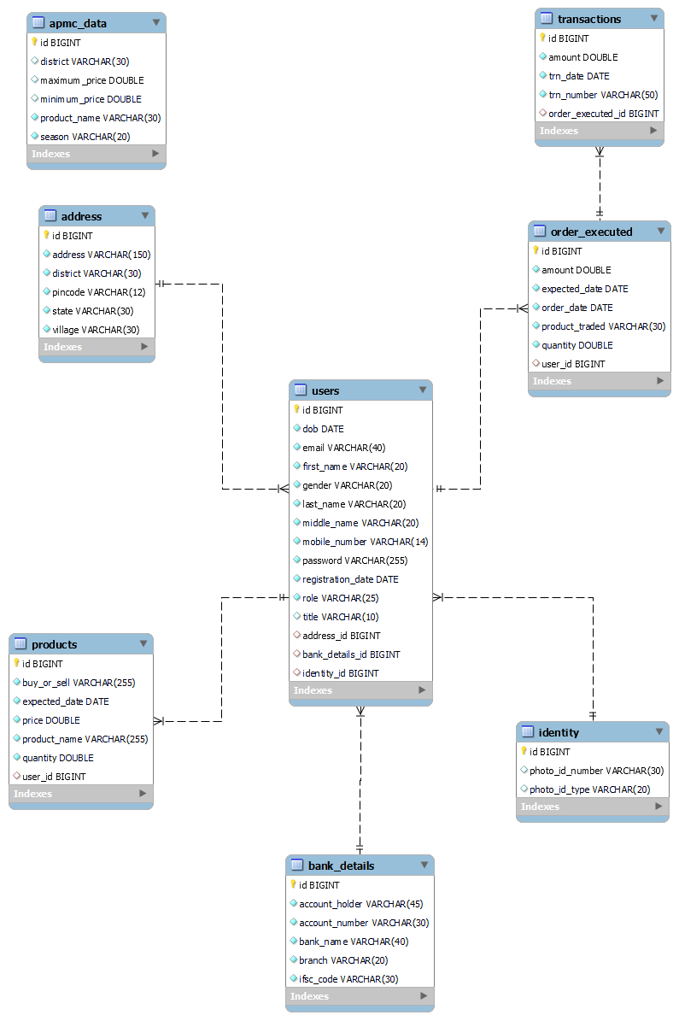

**3.2: BACK-END DEVELOPMENT:**

‘J2EE’ i.e ‘Jave Enterprise Edition’ has been used to implement the back-end i.e. server-side programming.

Spring-Boot framework is the core part for the back-end development. All the implementation has been done on ‘STS-IDE’, which is a ‘Eclipse-based’ IDE that has in-built plugins for Spring-Boot Application development.

Spring Boot is an open-source Java-based framework that is designed to simplify the development of web applications. It provides a set of tools and features that enable developers to quickly create and deploy production-ready applications with minimal configuration. Spring Boot builds on top of the Spring framework.

Spring Boot provides several benefits for back-end development. Firstly, it simplifies the development process by reducing the amount of boilerplate code required for configuring the application. Secondly, it provides a wide range of pre-built components and modules, such as RESTful APIs, database connectivity, security features, in-built ‘Apache Tomcat Server’ and more, which developers can easily integrate into their applications. Thirdly, it allows developers to package and deploy their applications as standalone executable JAR files, making deployment and maintenance easier.

Using Spring Boot for back-end development enables developers to focus on the core functionality of their applications rather than spending time on infrastructure and configuration. This results in faster development cycles and more robust, maintainable code. Additionally, Spring Boot has a large and active community of developers who contribute to the framework, providing regular updates and support.

Following is the basic architecture of a Spring-Boot project:

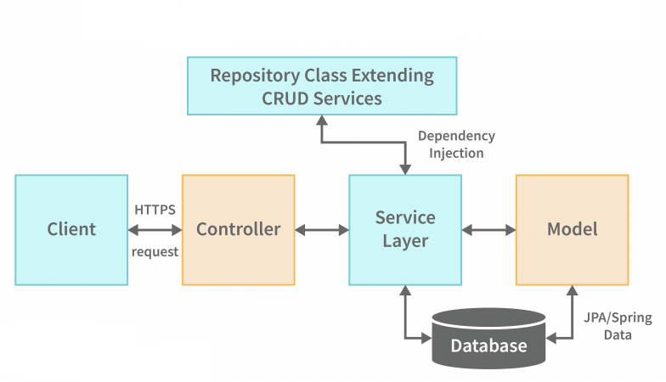

**3.2.1: CLIENT:**

* Client is a person who wishes to use the functionalities of the application. The client uses a ‘URL’ specified by the application developer.
* When the client enter this url in the browser, he/she sends an ‘HTTP-Request’ to the server of the application. This http request can be stateless or statefull.

**3.2.2: CONTROLLER:**

* Controller is a special type of class that receives the request from the client.
* When any type of http request is made by the client, it first goes to the controller class. ‘Home-Controller’ is the class that receives the request.
* On the basis of http request, the controller class decides where to forward the request. E.g. if the request received contains functionalities of ‘Admin’, the home-controller will forward the request to the ‘Admin-Controller’
* The code-snippet for the ‘Home-Controller’ looks like follow:

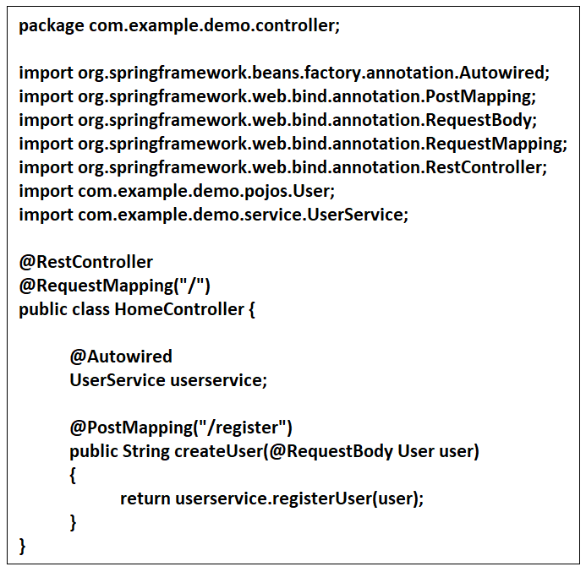

**3.2.3: SERVICE LAYER:**

* Service layer contains the actual business logic of the project. In service layer, all the logic and methods are declared and defined.
* Depending on the request received from the controller, the appropriate method inside the class gets called.
* The service layer is further divided into 2 categories:

1. Interfaces: The interfaces contain the declaration of the methods.
2. Classes: The classes contain the actual definition of the methods. These classes implement the particular interfaces.

This technique is used to achieve loose-coupling i.e. all the code should be independent of each other.

* Hence, all the required business logic could be found here. If there is a need of data from the database, the service layer communicates with the ‘Model’
* The code-snippet for the service layer looks like follow:
* UserService Interface:

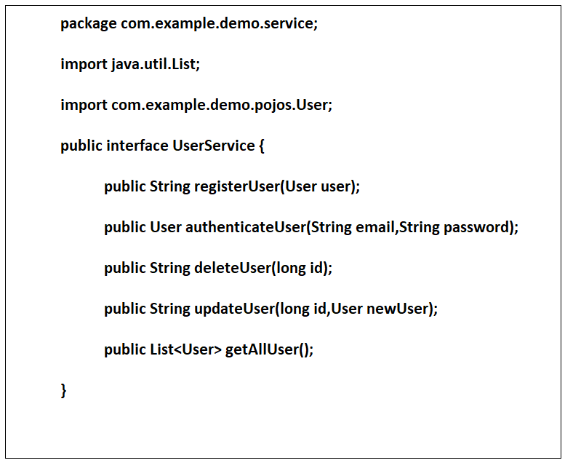

* UserServiceImpl Class:

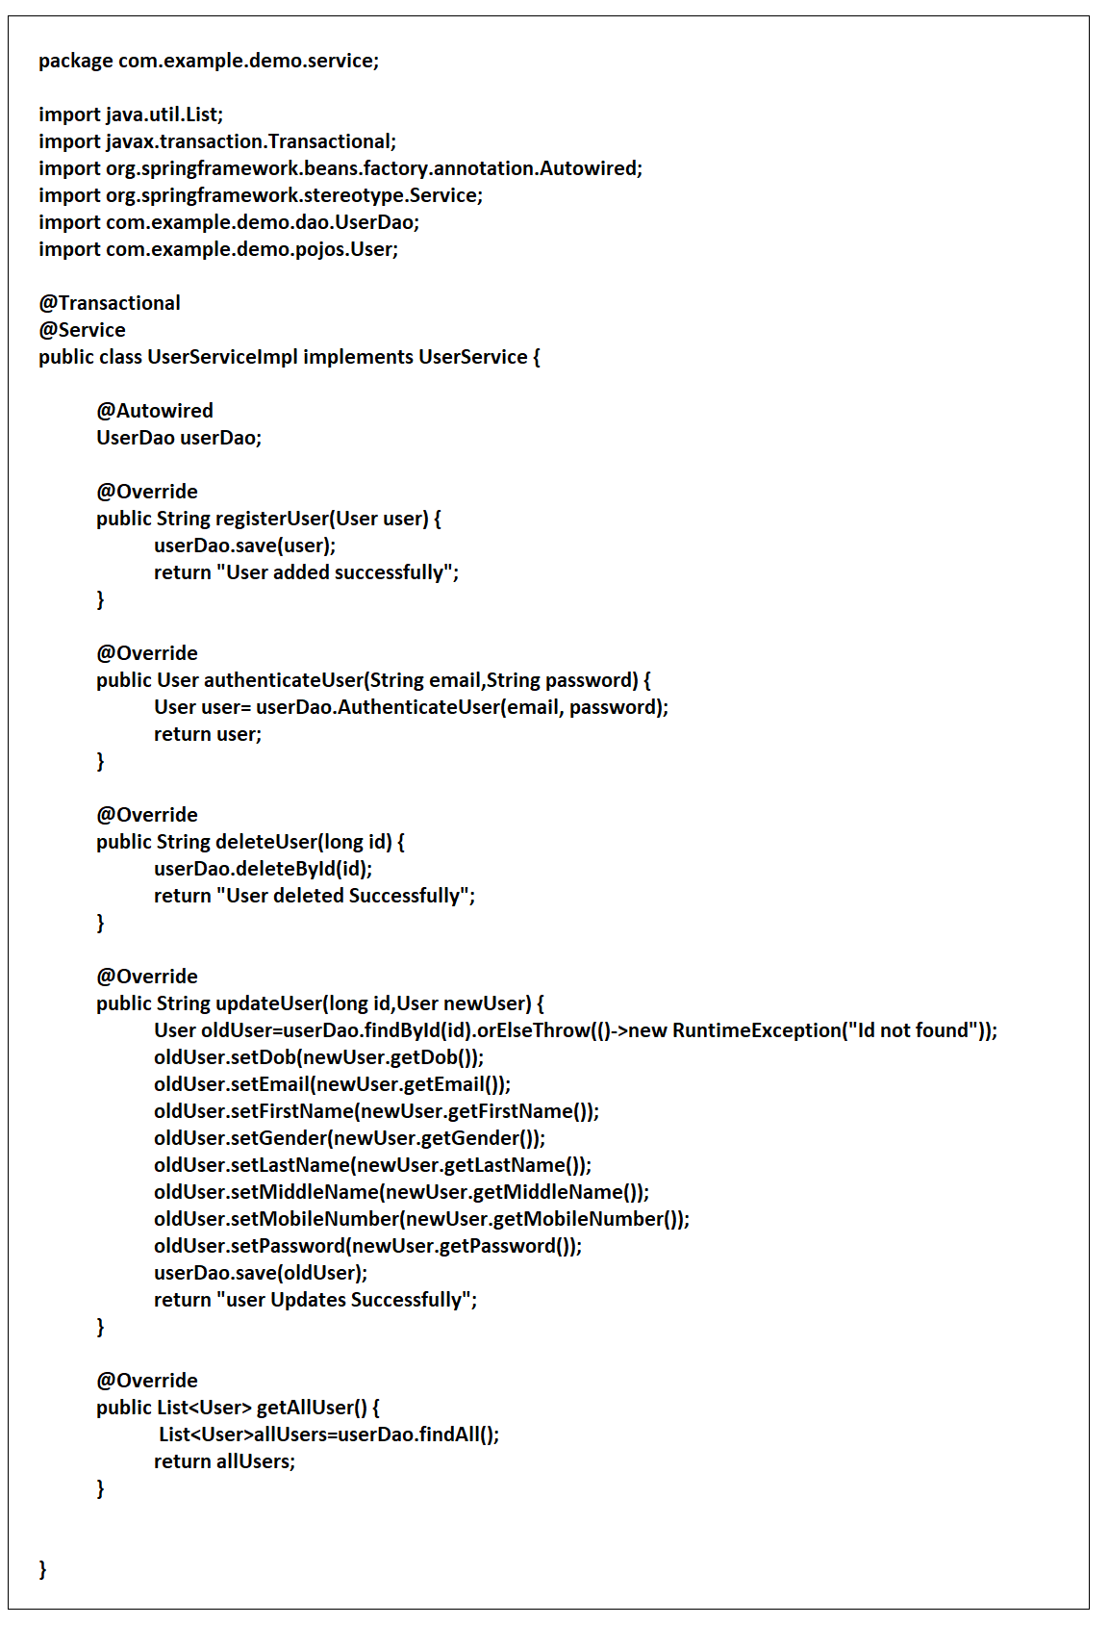

**3.2.4: MODEL:**

* Model, also called as DAO(Data Access Object) are the classes that actually communicates with the database.
* If service layer requests for data, then DAO communicates with the database and returns the same.
* DAO layer also contributes in adding data to the database.

**3.2: FRONT-END DEVELOPMENT:**

React-JS library has been used for development of the front-end i.e. client-side programming.

ReactJS is a popular JavaScript library that is primarily used for building user interfaces (UIs) for web applications. It was developed by Facebook and has gained significant popularity in recent years due to its simplicity, flexibility, and ability to efficiently handle large and complex applications.

ReactJS works by creating reusable components that can be used to build a UI. These components are small, modular pieces of code that represent different parts of the UI, such as a button, input field, or image. Components can be nested within each other to create more complex UI elements.

One of the key features of ReactJS is its use of a virtual DOM (Document Object Model), which is a lightweight representation of the actual DOM. When a user interacts with a React-based application, the virtual DOM is updated, and React compares the virtual DOM with the actual DOM to determine which parts of the UI need to be updated. This makes React very fast and efficient, as it only updates the parts of the UI that need to be changed, rather than re-rendering the entire UI.

ReactJS is also highly customizable and can be used with other libraries and frameworks, making it a versatile choice for building web applications. It is often used in combination with other front-end technologies, such as Redux for state management, React Router for routing, and Axios for handling HTTP requests.

Request forwarding flow:

* When a client enters the url in the browser, he gets redirected to the homepage of the application.
* The first page that client see is the ‘index.html’.
* Index.html is the first page that loads in the browser. In this page, there is a single ‘<div></div>’.
* This ‘div’ receives data from index.js, which is a javascript file, which has ‘javascript and html’ code.
* This index.js file has a function which returns a component called ‘App’.
* Now, this component is written in another ‘App.js’ file. You need to import the dependent files in your depending files.
* Now, this ‘App,js’ has all the code that renders the homepage. In this file, there is a function that returns all the components that user wants to display on the webpage.
* Thus, using this technique, we can achieve modularity and loose-coupling.
* All these pages have their own ‘.css’ file, which provides styling to the webpage.
* Following is the code-snippet that describes a basic ‘index.js’ file:

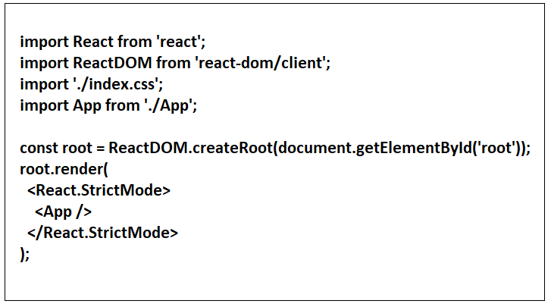

**3.4: SECURITY:**

In this project, Spring-Security has been used to implement the security.

Spring Security is a powerful and highly customizable framework for managing security in Java applications. It is built on top of the Spring Framework and provides a variety of features for securing web applications, RESTful services, and microservices.

The primary goal of Spring Security is to provide a flexible and robust security architecture that can be easily integrated into existing Spring-based applications. It includes a number of features to help developers implement authentication, authorization, and other security-related functionality.

One of the key features of Spring Security is its support for a wide range of authentication mechanisms, including username/password authentication, token-based authentication, and OAuth 2.0 authentication. Spring Security also provides support for multi-factor authentication and integration with third-party identity providers, such as Google and Facebook.

In addition to authentication, Spring Security also provides robust authorization functionality. Developers can easily define authorization rules using expressions, annotations, or custom security filters. This allows them to control access to specific resources or functionalities based on a user's role or other criteria.

Spring Security also includes features for handling common security-related tasks, such as password hashing, CSRF protection, and session management. It can also

integrate with other Spring frameworks, such as Spring Data and Spring MVC, to provide a comprehensive security solution for Java applications.

Overall, Spring Security is a powerful and flexible framework for managing security in Java applications. Its broad range of features and easy integration with other Spring frameworks make it a popular choice for developers looking to add robust security to their applications.

The Authorization Controller class code looks like following:

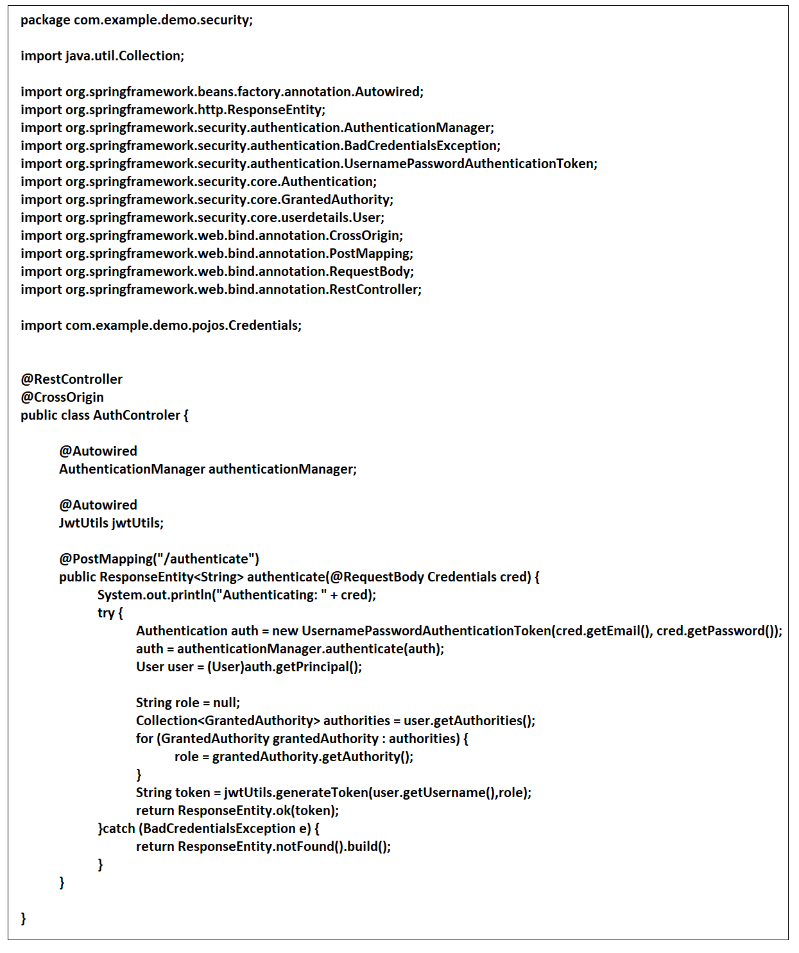

**3.5: INTEGRATION:**

Spring Boot and React can be integrated to build modern web applications with a scalable and efficient architecture.

Spring Boot is a popular Java-based framework used for building web applications. It provides many features, including auto-configuration, embedded server, and simplified dependency management, which makes it easy to set up and run a Spring application.

React, on the other hand, is a JavaScript library used for building user interfaces. It is a popular choice for front-end development due to its performance, flexibility, and ability to create reusable components.

To integrate Spring Boot and React, one approach is to build a RESTful API with Spring Boot that can be consumed by a React-based front-end. This can be achieved by using the Spring MVC framework to handle HTTP requests and responses and exposing the API endpoints as RESTful services.

On the React side, the UI can be built using React components that consume the API endpoints exposed by the Spring Boot application. React components can be organized into a component hierarchy and can interact with the API using Axios, a popular HTTP client library for JavaScript.

To make it easier to deploy and manage the integrated application, Spring Boot can be configured to serve the React-based UI as a static resource. This can be done by placing the React build files in the Spring Boot application's resources/static directory, allowing the React UI to be served by the Spring Boot embedded server.

Overall, integrating Spring Boot and React can result in a powerful and scalable architecture for building modern web applications. The combination of Spring Boot's robust back-end capabilities and React's flexible front-end components can help developers build applications that are easy to maintain, scalable, and efficient.

**3.6: DEPLOYMNET:**

1. **TESTING:**

The testing has been done by visiting each page, and checking whether any page generates any error while loading or if the user enters an inappropriate data.

Following table depicts all the results generated while testing.

|  |  |  |  |  |
| --- | --- | --- | --- | --- |
| **SR. NO.** | **TEST CASE** | **EXPECTED RESULT** | **ACTUAL RESULT** | **MESSAGE** |
|  |  |  |  |  |
| 1 | Home Page Visit | User should be able to see all the buttons, UI and page should load fast. | Same as expected. | - |
| 2 | Login | When user clicks on Login, he/she should get redirected to Login page, where he/she can login or register | Same as expected. | * Login successful!! (for valid credentials) * Invalid Credentials (for invalid credentials) |
| 3 | Register | User should be able to enter all the required fields. If user enters invalid details, or leaves any field empty, he/she should receive an error. On successful registration, he/she should get redirected to login page. | Same as expected. | * User Registered Successfully (if all details are valid) * Invalid details (if details entered are invalid, or empty field detected) |
| 4 | Weather | User should be able to check weather of the selected district. | Same as expected. | - |
| 5 | APMC | User should be able to check the APMC data. | Same as expected. | - |
| 6 | Add Product (Seller) | Seller should be able to enter his product details. On successful addition, user should be redirected to ‘My Orders’.  If invalid details are entered or field is left empty, user should receive an error. | Same as expected. | * Product added successful (if details are valid) * Invalid details (for invalid/empty details) |
| 7 | My Products  (Seller) | Seller should be able to see all his/her pending products. Also, should be able to delete invalid product details. | Same as expected. | - |
| 8 | Search for buyer  (Seller) | Seller should be able to see all the pending requests on the platform. If he/she has the required product, he/she can click on ‘sell’ button. | Same as expected. | - |
| 9 | My Orders/  Transactions  (Seller) | Seller should be able to check his/her previous orders. Also, when he/she clicks on ‘Transaction’ button, should be able to check transaction details for that particular order. | Same as expected. | - |
| 10 | Edit Profile (Seller) | Seller should be able to edit profile and change basic details. Seller can not change email id. | Same as expected. | - |
| 11 | Add Requirement (Buyer) | Buyer should be able to enter his requirements. On successful addition, user should be redirected to ‘My Requirements’.  If invalid details are entered or field is left empty, user should receive an error. | Same as expected. | * Requirement added successful (if details are valid) * Invalid details (for invalid/empty details) |
| 12 | My Requirements  (Buyer) | Buyer should be able to see all his/her pending requirements. Also, should be able to delete invalid requirement details. | Same as expected. | - |
| 13 | Search for seller  (Buyer) | Buyer should be able to see all the pending requests on the platform. If he/she has the required product, he/she can click on ‘buy’ button. | Same as expected. | - |
| 14 | My Orders/  Transactions  (Buyer) | Buyer should be able to check his/her previous orders. Also, when he/she clicks on ‘Transaction’ button, should be able to check transaction details for that particular order. | Same as expected. | - |
| 15 | Edit Profile (Buyer) | Buyer should be able to edit profile and change basic details. Buyer can not change email id. | Same as expected. | - |
| 16 | All Users (Admin) | Admin should be able to check all users including buyers, sellers and admins. Admin can delete invalid or inactive user. | Same as expected. | - |
| 17 | All Orders/  Transactions (Admin) | Admin should be able to check all executed orders on the platform and can check the respective transaction. | Same as expected. | - |
| 18 | All Products (Admin) | Admin should be able to all the products as well as requirements on the platform. | Same as expected. | - |
| 19 | Edit Profile (Admin) | Admin should be able to edit his/her profile. | Same as expected. | - |
| 20 | Logout | User should be able to see ‘Log out’ button after successful login. On logout, he/she should get redirected to sign in page | Same as expected. | User Logged Out Successfully. |

1. **USER INTERFACE**

* Home Page:

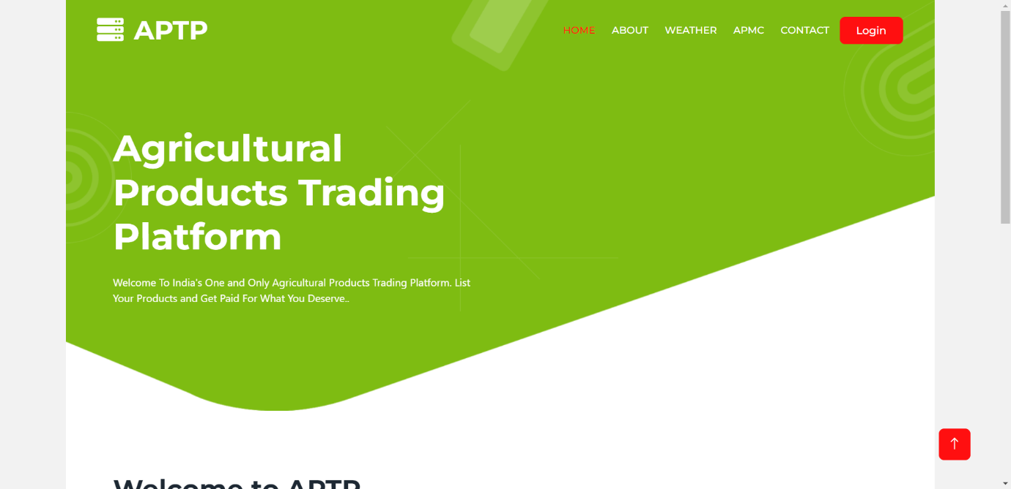

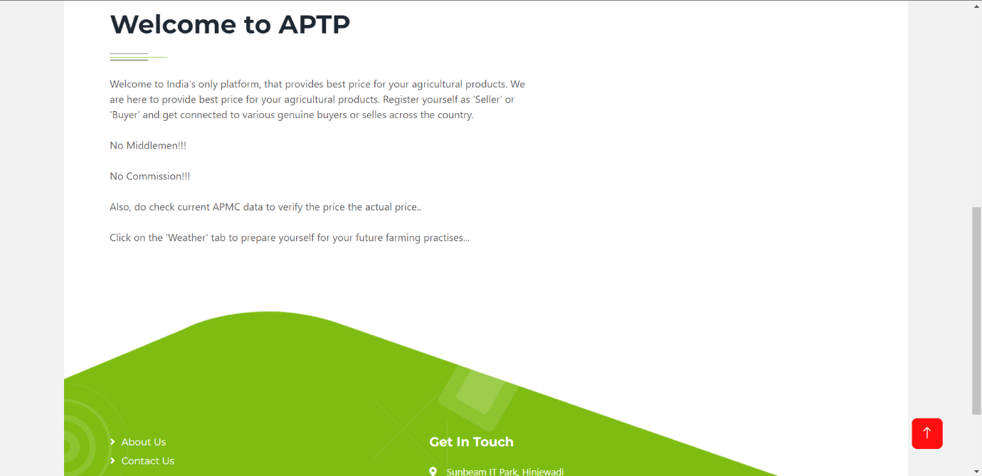

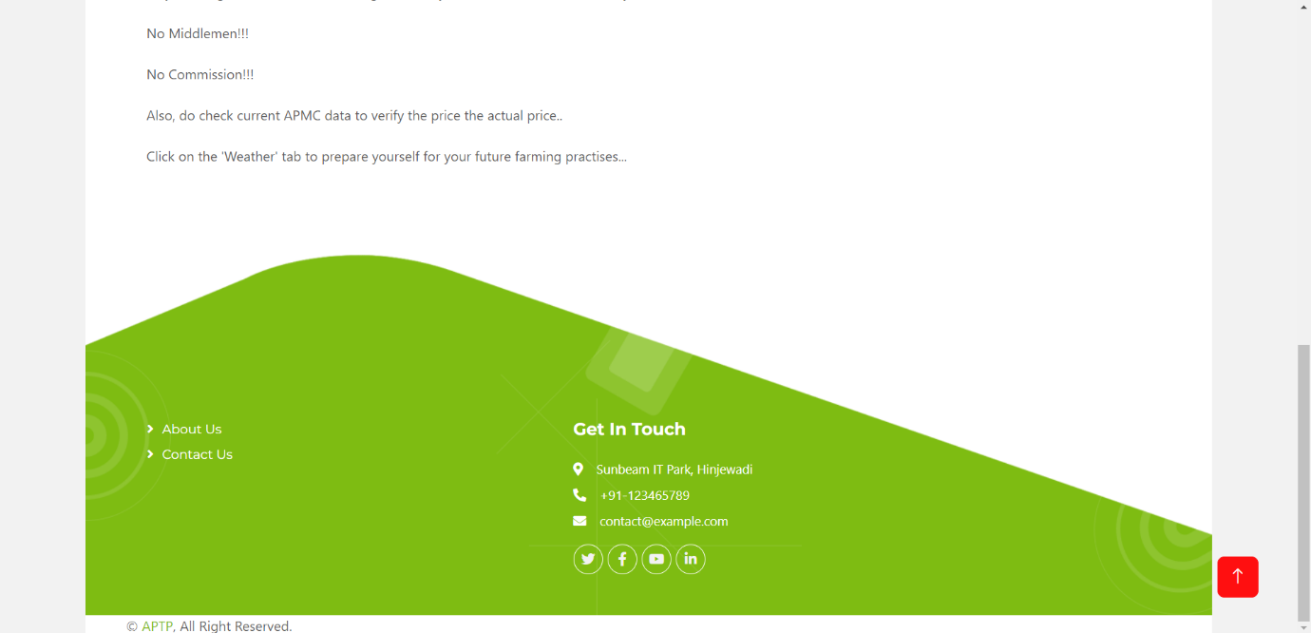

* About Us Page:

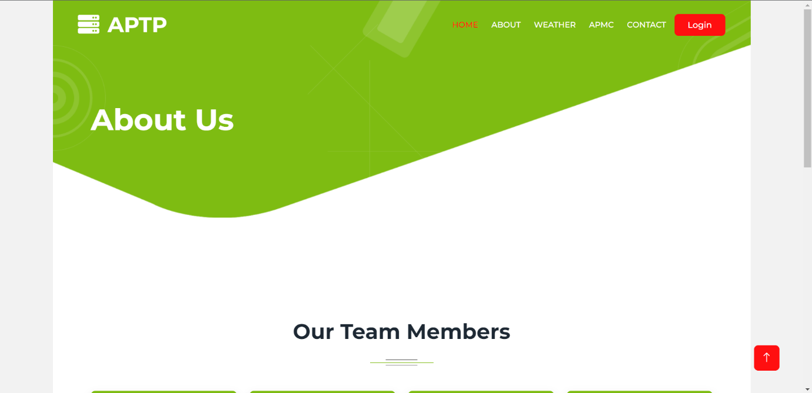

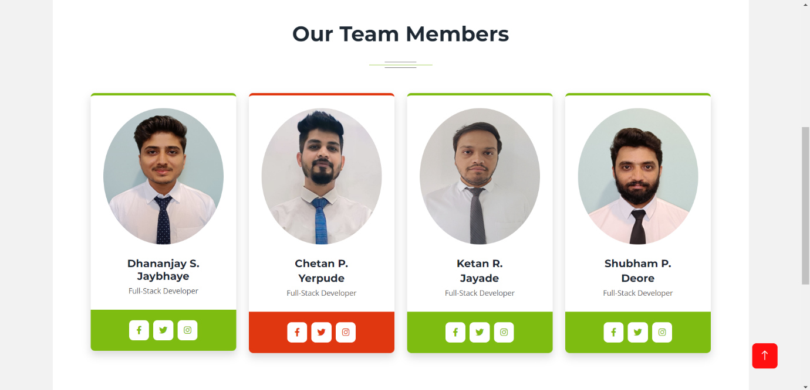

* Contact Us Page:

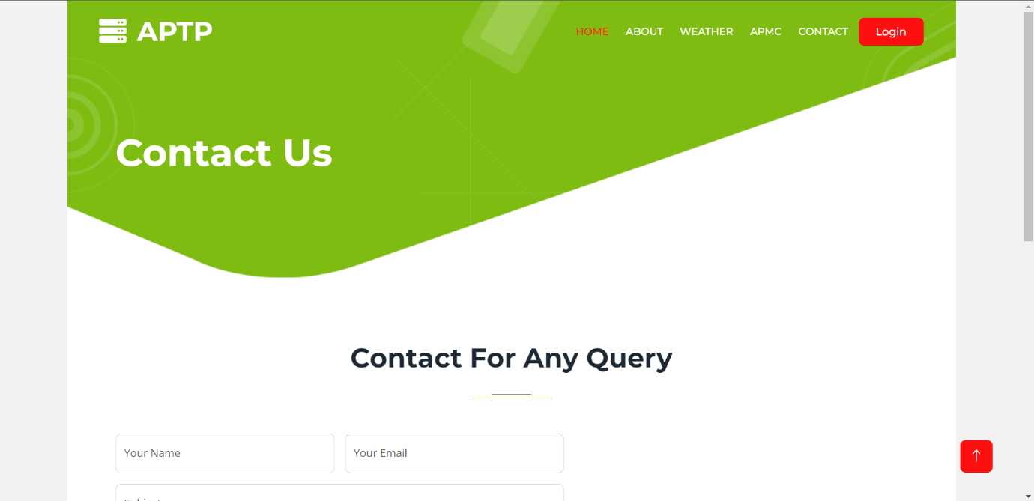

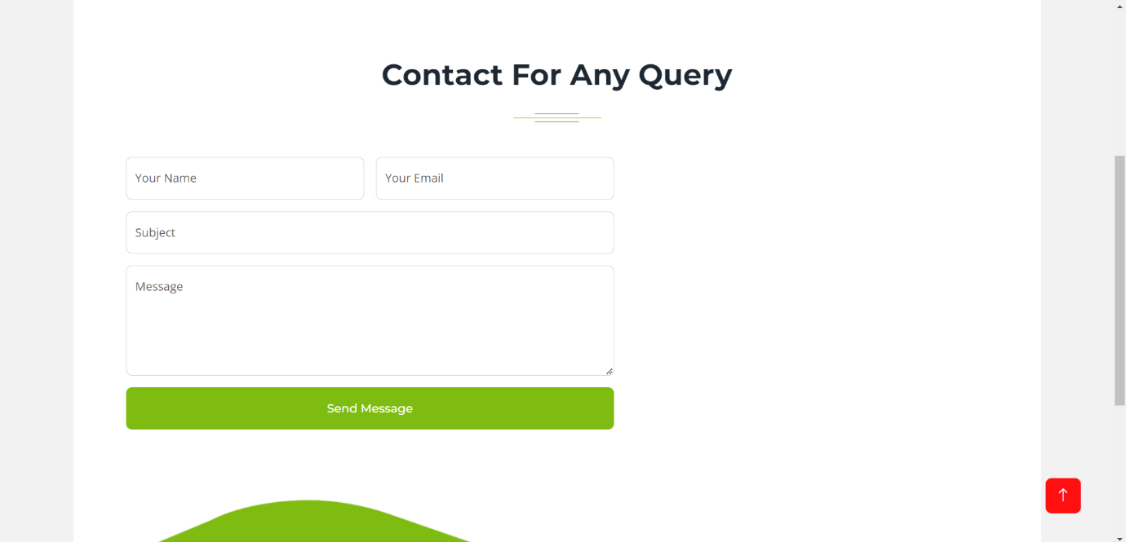

* Login Page:

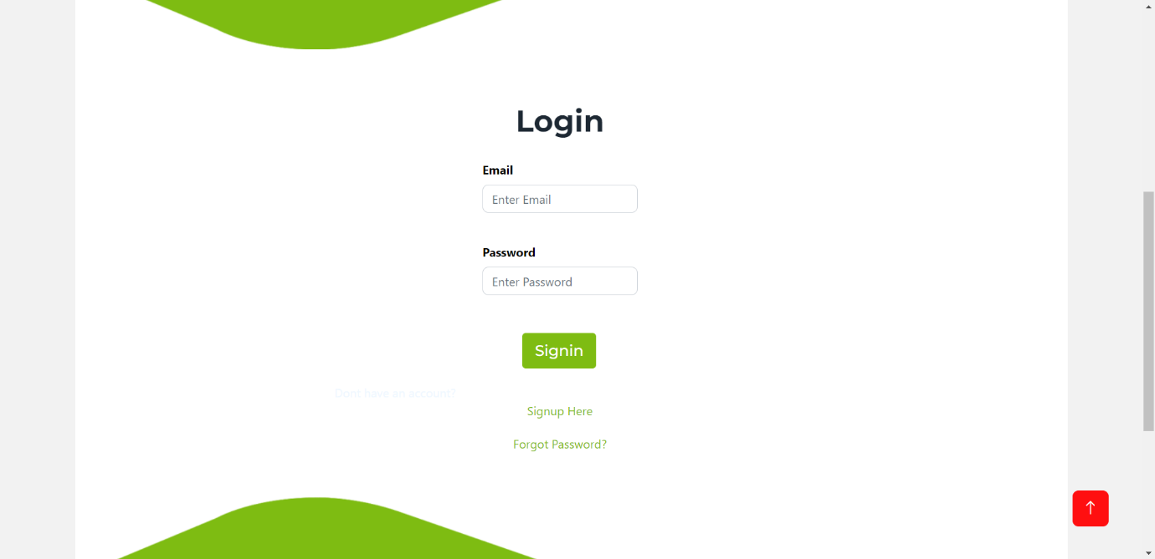

* Registration Page:

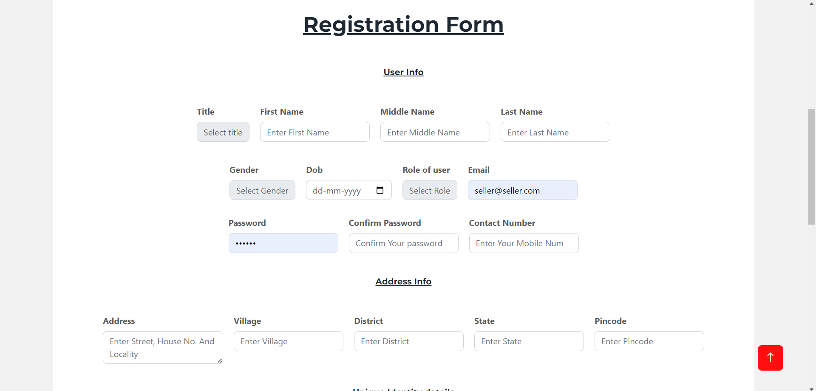

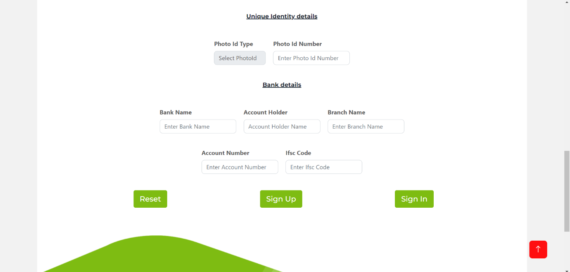

* Forgot Password Page:

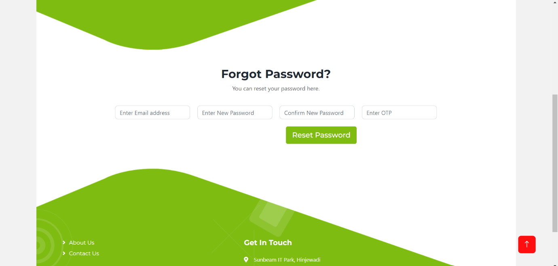

* Admin Login:
* Admin Dashboard:

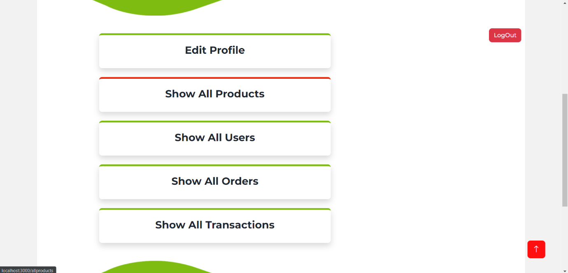

* Admin Edit Profile:

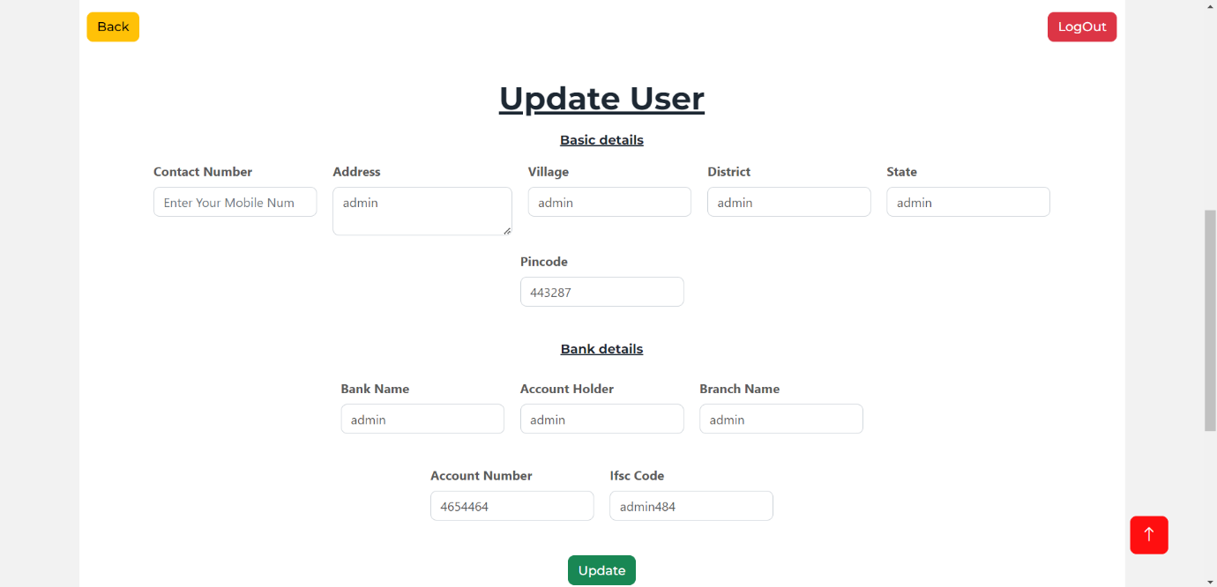

* Admin Show All Products:

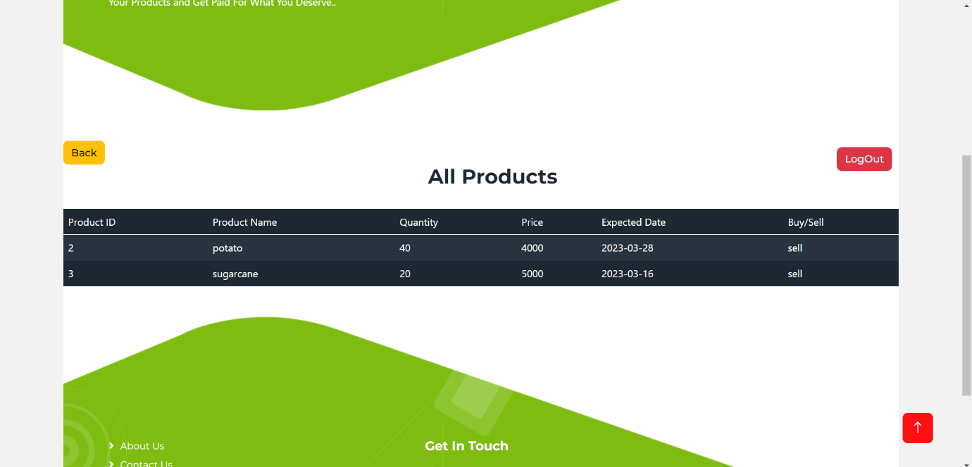

* Admin Show All Transactions:

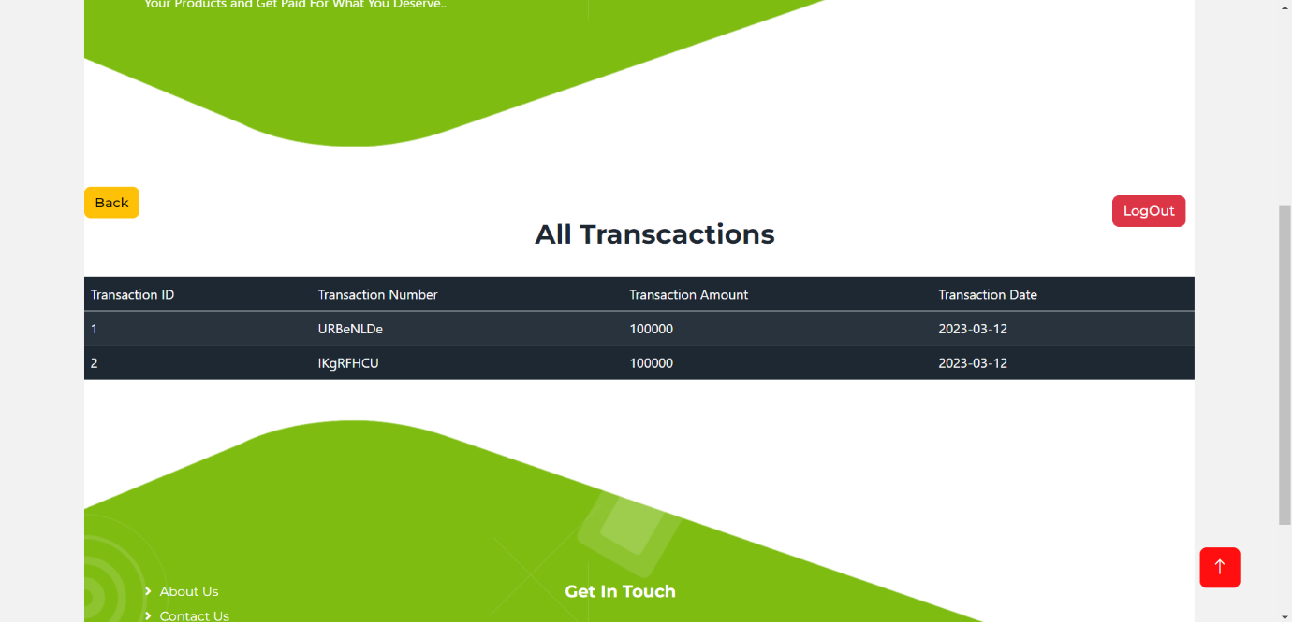

* Admin Show All Orders:

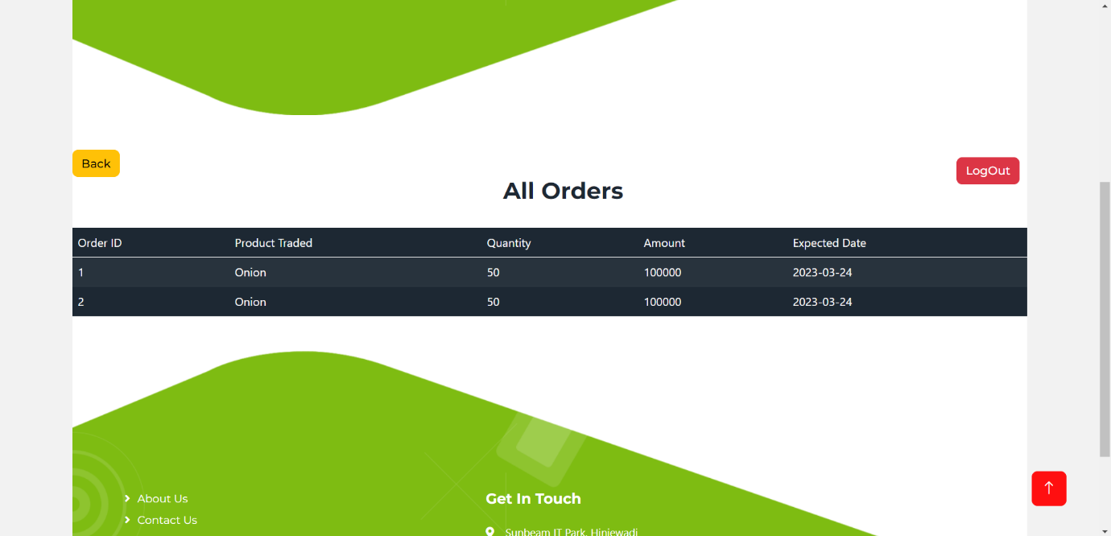

* Admin Show All Users:

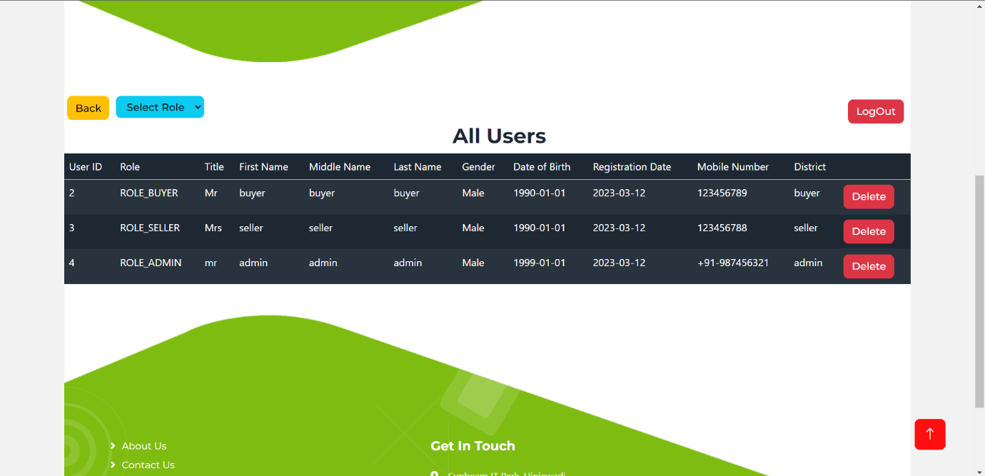

* Buyer Login:
* Buyer Dashboard:

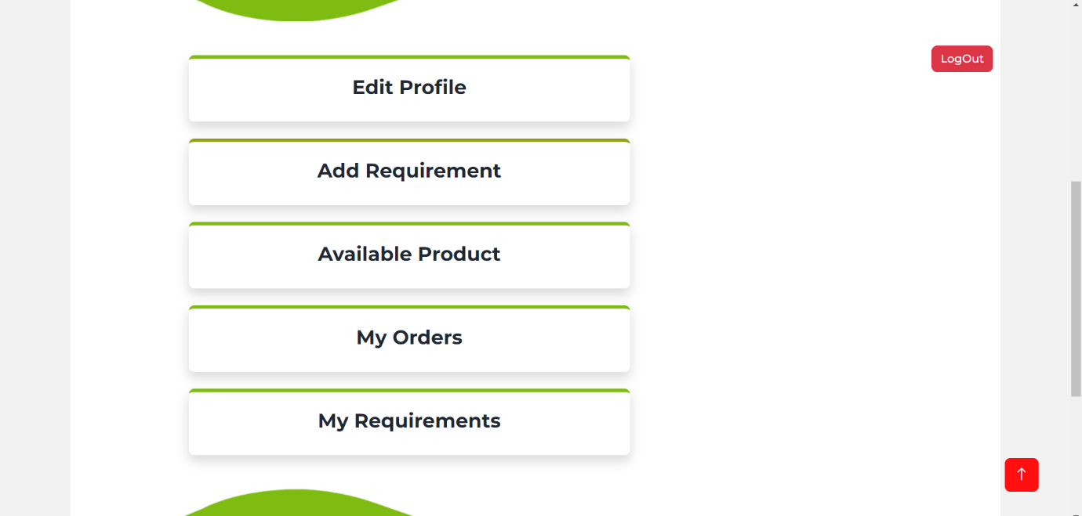

* Buyer Edit Profile:

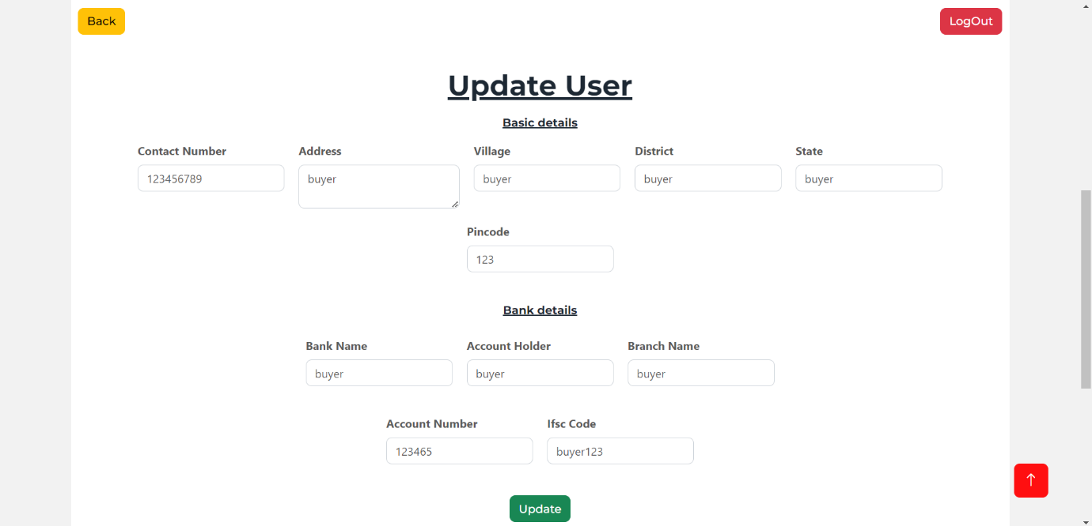

* Buyer Add Requirement:

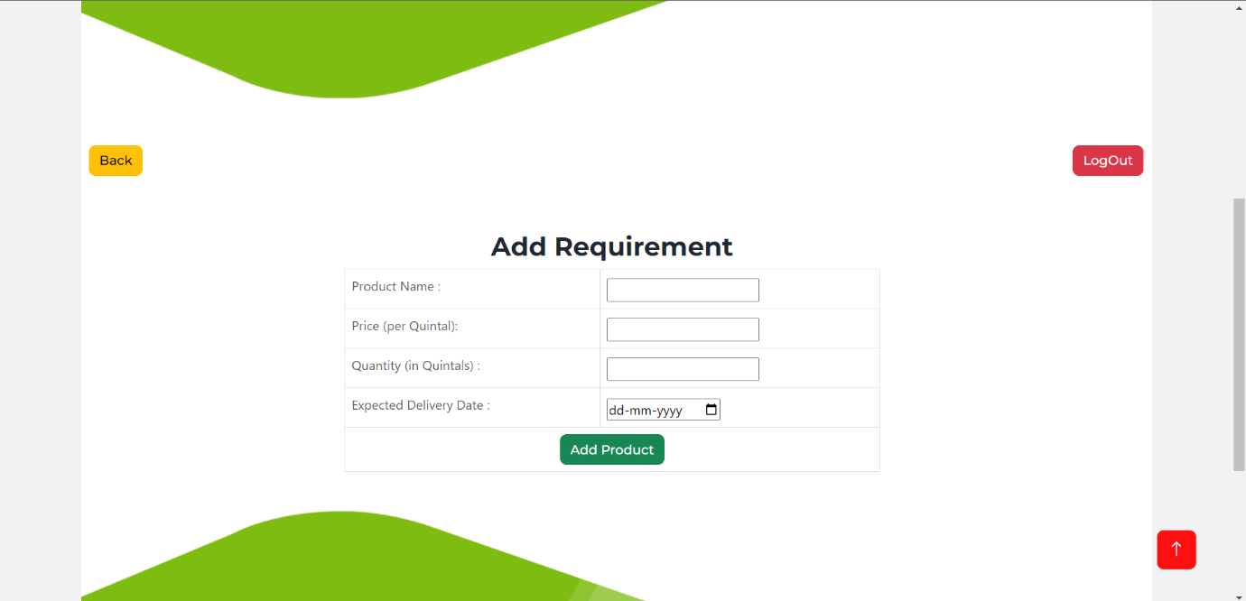

* Buyer Available Products:

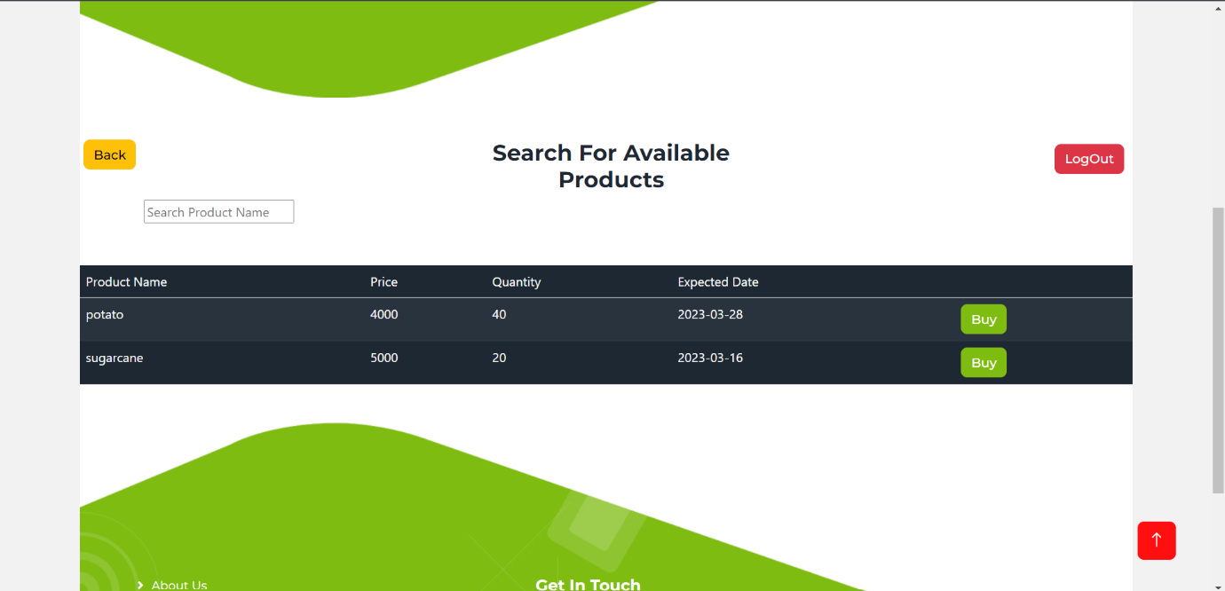

* Buyer My Orders:

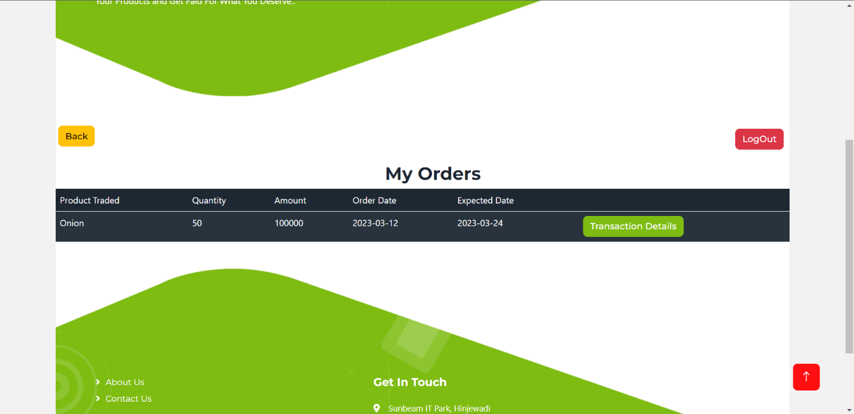

* Buyer Transaction Details:

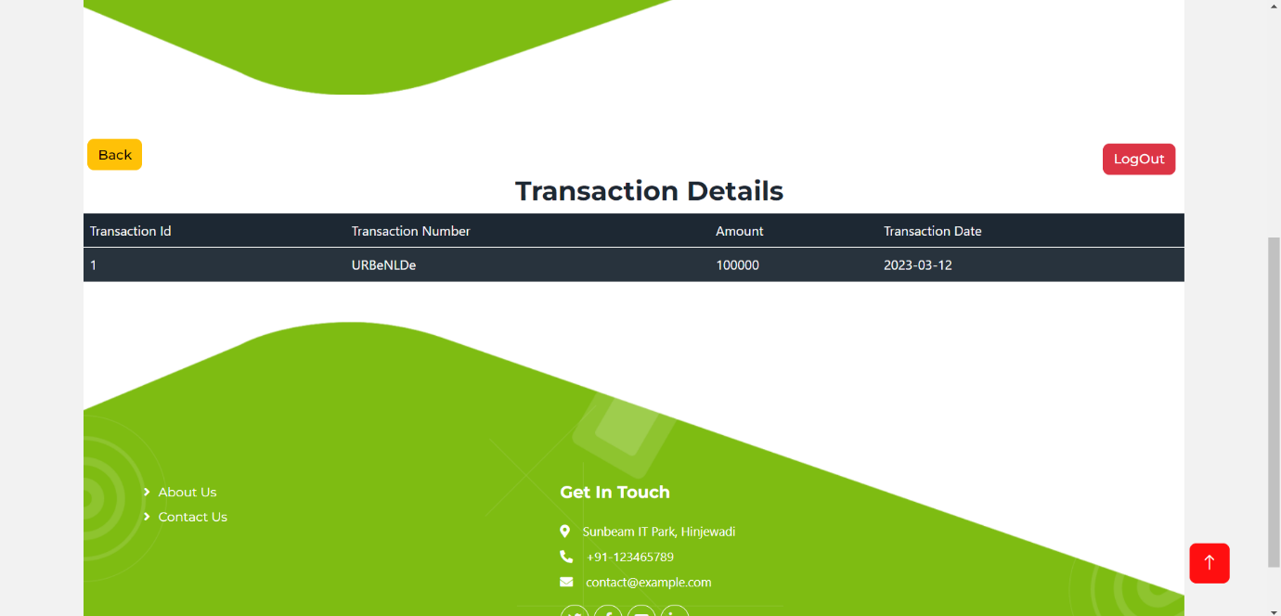

* Buyer My Requirements:

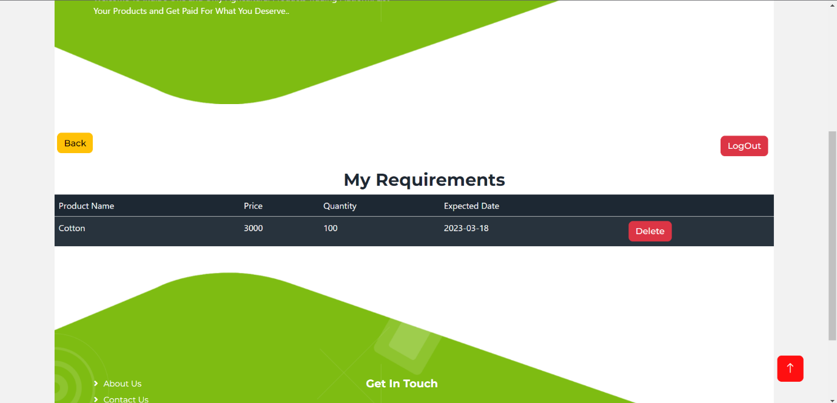

* Seller Login:
* Seller Dashboard:

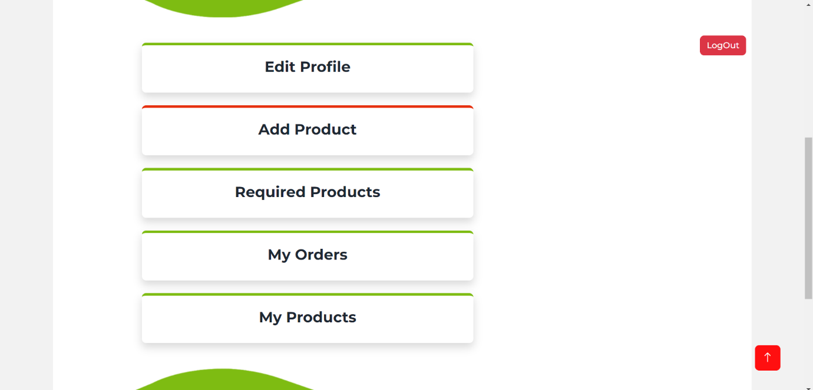

* Seller Edit Profile:

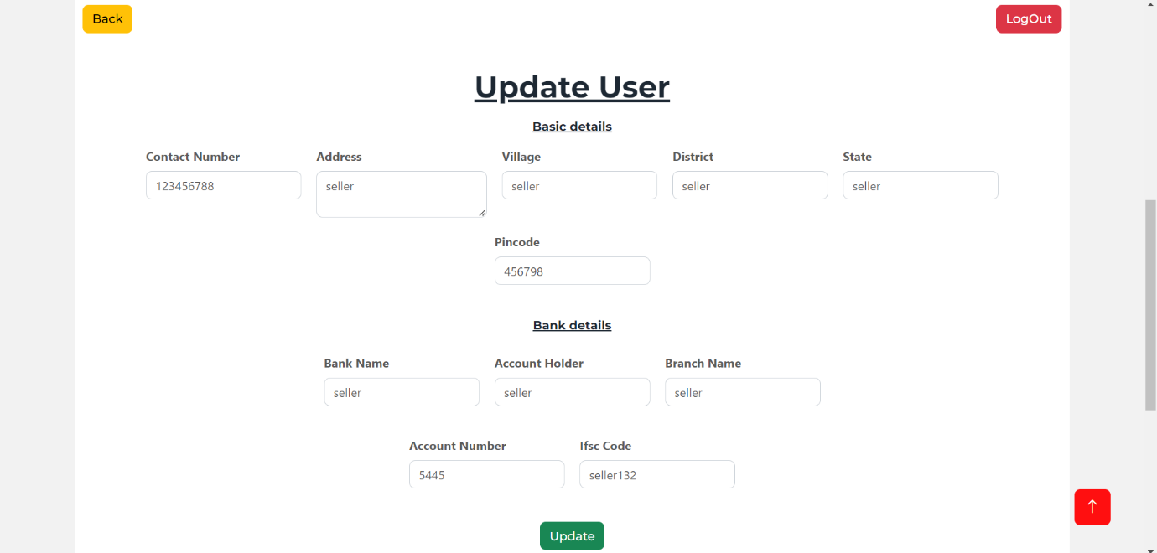

* Seller Add Product:

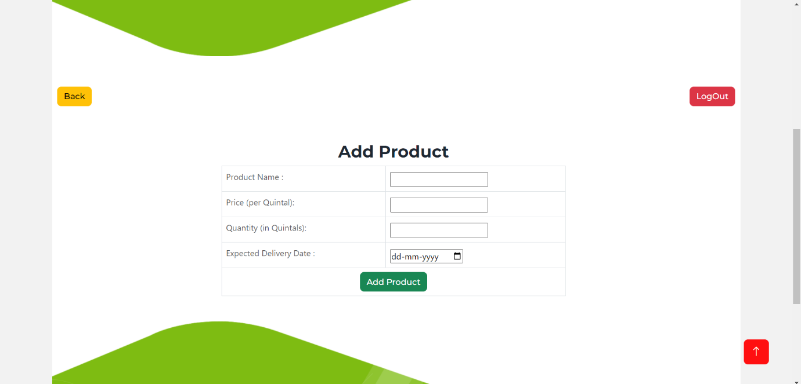

* Seller Required Products:

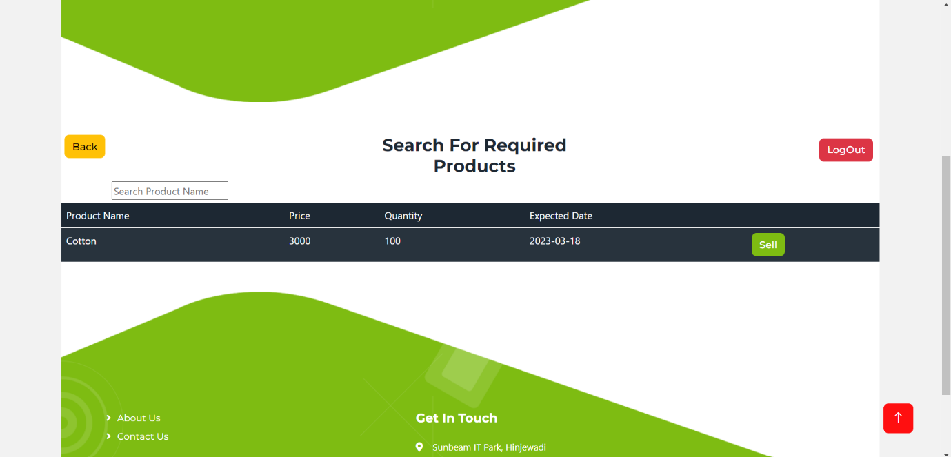

* Seller My Orders:

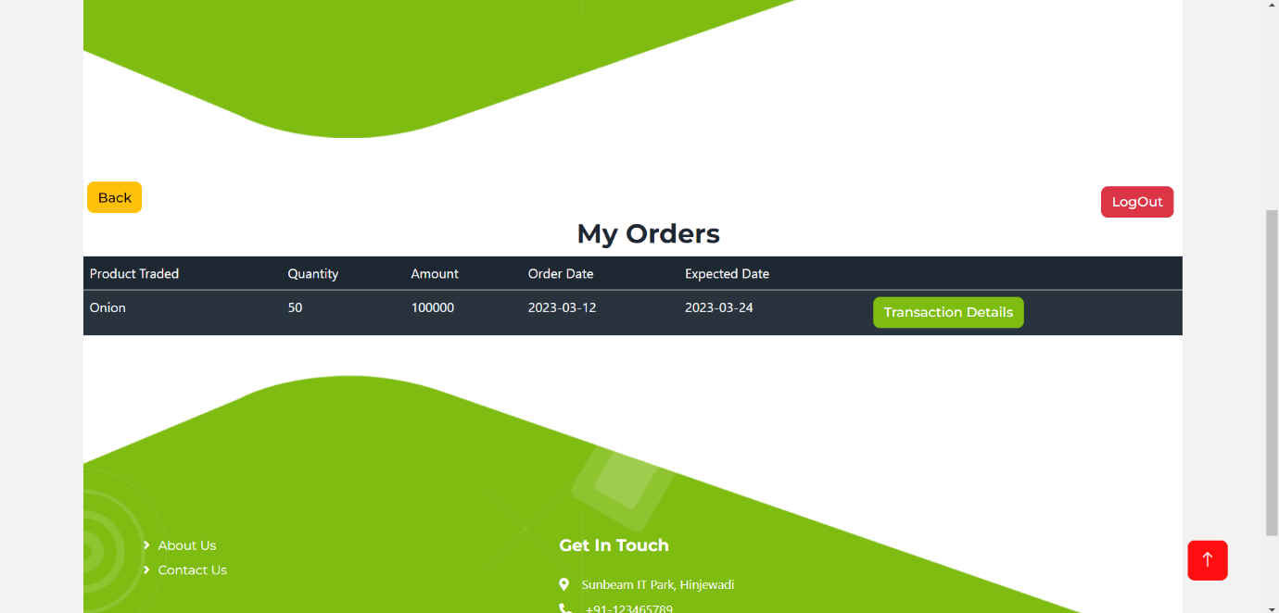

* Seller Transaction Details:

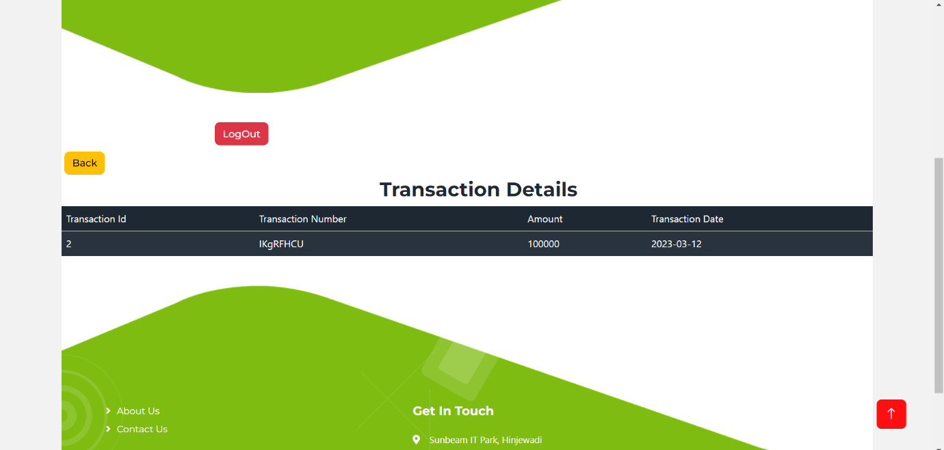

* Seller My Products:

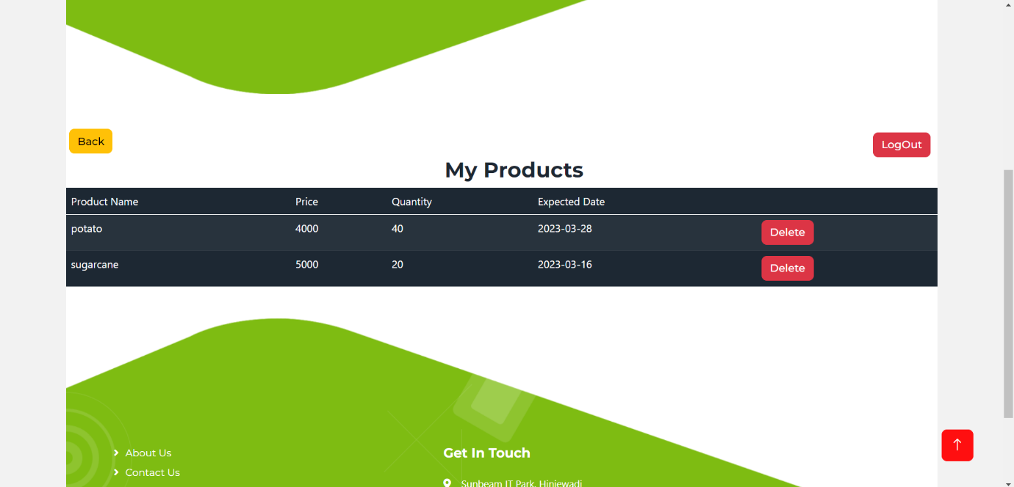

1. **CODING STANDARDS IMPLEMENTED**

**Naming and Capitalization**

Below summarizes the naming convention for identifiers in Pascal casing is used mainly (i.e., capitalize first letter of each word) with camel casing (capitalize each word except for the first one) being used in certain circumstances.

|  |  |  |  |
| --- | --- | --- | --- |
| **IDENTIFIER** | **CASE** | **EXAMPLES** | **DESCRIPTION** |
|  |  |  |  |
| Class | Pascal | User, Product, OrderExecuted, Transaction, etc. | Class names should be based on "objects" or "real things" and should generally be **nouns**. No ‘_’ signs allowed. Do not use type prefixes like ‘C’ for class. |
| Method | Camel | getAllUsers, getAllProducts, getMyOrders, etc | Methods should use verbs or verb phrases. |
| Parameter | Camel | first_name, dob, etc. | Use descriptive parameter names. Parameter names should be descriptive enough that the name of the parameter and its type can be used to determine its meaning in most scenarios. |
| Interface | Pascal | ProductDao, UserDao, UserService, etc. | Do not use the ‘_’ sign |
| Exception Class | Pascal with “Exception” suffix |  |  |

**Comments**

* Comment each type, each non-public type member, and each region declaration.
* Use end-line comments only on variable declaration lines. End-line comments are comments that follow code on a single line.
* Separate comments from comment delimiters (apostrophe) or // with one space.
* Begin the comment text with an uppercase letter.
* End the comment with a period.
* Explain the code; do not repeat it.